**Indoor Posting the Colors**

[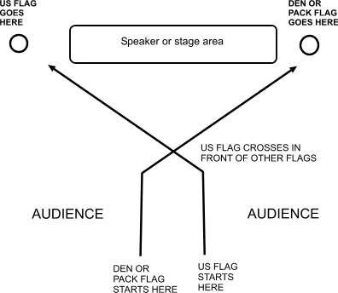](http://10dyuk2k99c42ykeneovawpk.wpengine.netdna-cdn.com/wp-content/uploads/flag-ceremony.jpg)

**Leader**: “Audience please rise, Scouts ATTENTION!”

*The audience rises. Scouts stand at attention.*

**Leader**: “Color Guard, ADVANCE. SCOUT SALUTE.”

*Scouts carrying the US & Pack or den flags start walking. Those in uniform do a hand salute.*

*Everyone else places their hand on their heart.*

**Once at the flag posts - Leader**: “Please join us in the Pledge of Allegiance.

I pledge allegiance …”

*The audience says the Pledge of Allegiance.* *The US Flag stays fully up rite, The all-other flags dip during the pledge*

**Leader**: “TWO.”

*Everyone stops saluting.*

**Leader**: “Color Guard, POST THE COLORS

**Leader**: “Color Guard, RETREAT.”

*The color guard walks back to starting point.*

**Leader**: “Color Guard, DISMISSED.”

*The Color Guard goes to their Den or Patrol.*

**Indoor Retrieving the Colors**

**Leader**: “Audience please rise, SCOUTS ATTENTION!”

*The audience rises. Scouts stand at attention.*

**Leader**: “Color Guard, ADVANCE.”

*Scouts in the Color Guard start walking.*

**Leader**: “SCOUTS SALUTE!”

*Those in uniform salute.*

*Everyone else places their hand on their heart.*

**Leader**: “Color Guard, RETRIVE THE COLORS”

**Leader**: “Color Guard, RETREAT.”

*The color guard walks back to starting point. No need to cross over as the flags are in the proper position.*

**When Color Guard is at starting point - Leader**: “TWO.”

*Everyone stops saluting.*

**Leader**: “Color guard, DISMISSED.”

*The Color guard stores the flag and goes to their Den or Patrol.*

**Outdoor Posting the Colors**

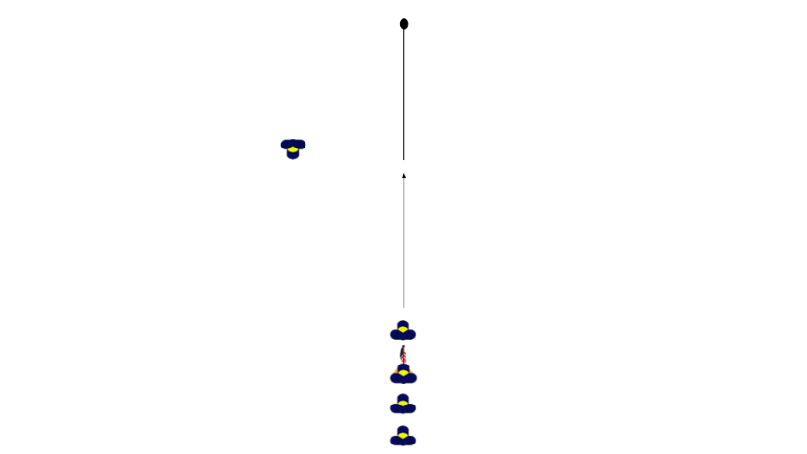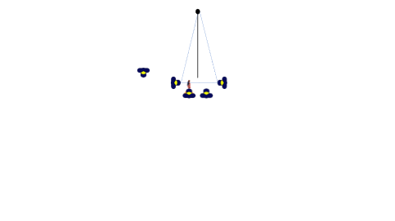

**Leader:** “Audience please rise (if seated), Scouts ATTENTION!”

*The audience rises. Scouts stand at attention.*

**Leader:** “Color Guard, ADVANCE. SCOUT SALUTE.”

*Scouts carrying the US & Pack or den flags start walking.*

*Those in uniform do a hand salute. Everyone else places their hand on their heart.*

**Leader:** “Color Guard, POST THE COLORS

The Color Guard will break off into their jobs and raise the colors

**As soon as the colors are to the top - the Leader:** “Please join us in the Pledge of Allegiance.

I pledge allegiance …” *The audience says the Pledge of Allegiance.*

*All-other flags dip during the pledge*

**Leader:** “TWO.”

*Everyone stops saluting.*

**Leader:** “Color Guard, RETREAT.”

*The color guard walks back to starting point.*

**Leader:** “Color Guard, DISMISSED.”

*The Color Guard goes to their Den or Patrol.*

**Outdoor Retrieving the Colors**

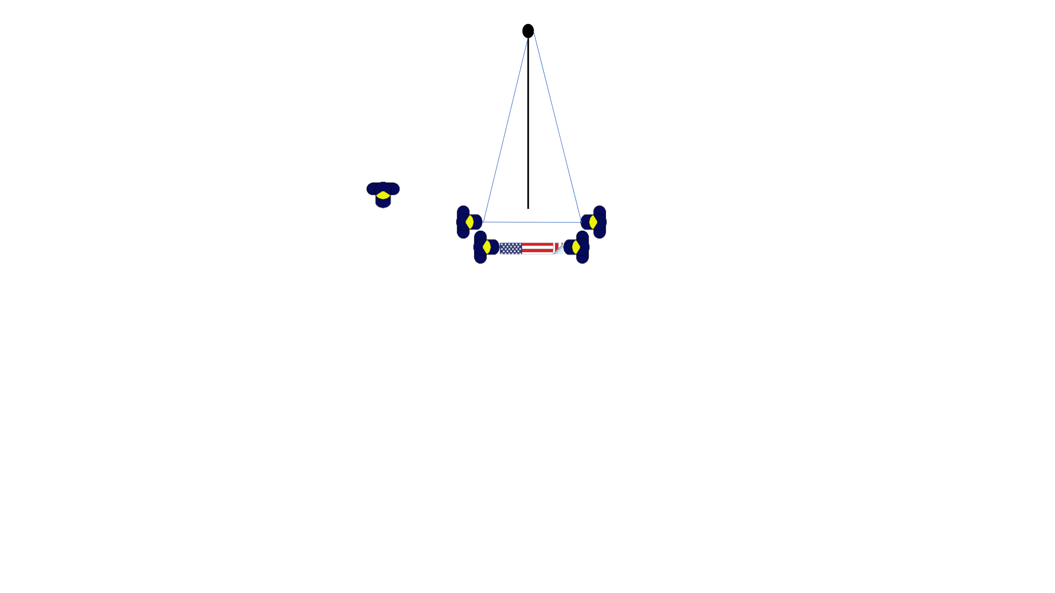 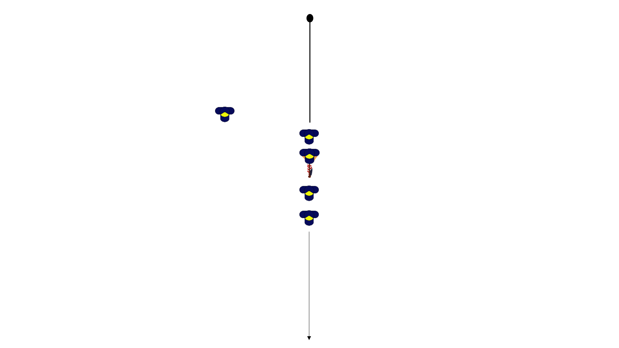

**Leader:** “Audience please rise (if seated), SCOUTS ATTENTION!”

*The audience rises. Scouts stand at attention.*

**Leader:** “Color Guard, ADVANCE.”

*Scouts in the Color Guard start walking.*

*When the Color Guard arrives at the pole, they break formation and start their assigned duties.*

**Once all members of the Color Guard are ready - Leader:** “SCOUTS SALUTE!”

*Those in uniform salute. Everyone else places their hand on their heart.*

**Leader:** “Color Guard, RETRIVE THE COLORS”

*Color Guard proceeds to lower the colors. Once down and unhooked the flag is folded*

**Once the flag is folded and the Color Guard is in formation - Leader:** “Color Guard, RETREAT.”

*The color guard walks back to starting point.*

**When Color Guard is at starting point - Leader:** “TWO.”

*Everyone stops saluting.*

**Leader:** “Color guard, DISMISSED.”

*The Color guard stores the flag and goes to their Den or Patrol.*